Software Requirement :

- We have used NetBeans 8.1 for the front-end development.
- JDBC 4.0 as database connector .
- SQL Server Management Studio 2008 for the database.

Execution :

UI.java :

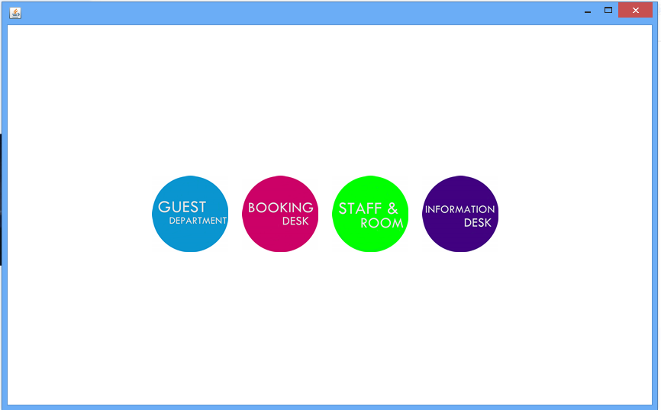

- When we run the project, this window will show first.
- There are 4 icon which are Guest Department, Booking Desk, Staff Room, Information Desk.
- By clicking this icon we can go to the next page and it will show the information about it.

Guest Department :
Add :
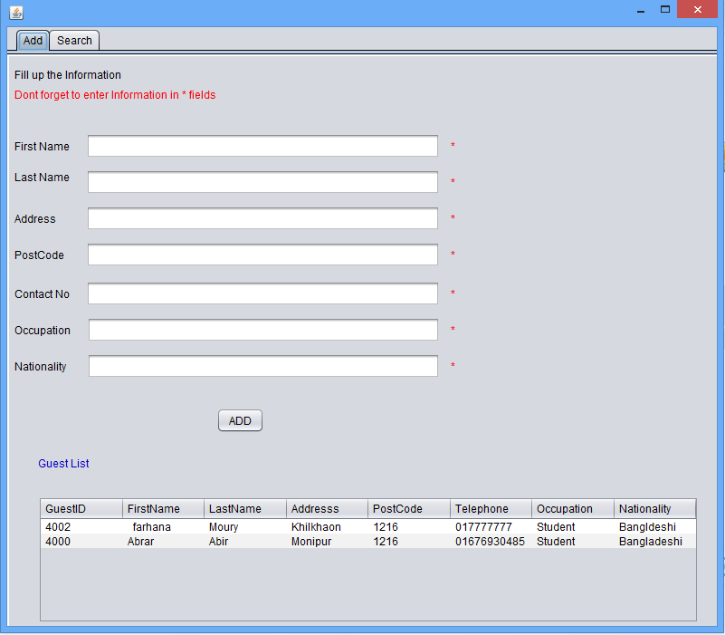
- If we click the guest department icon, this tab will be shown.
- This table add the info of the guests before booking in the hotel.
- It also shows the guests list and info like - name, address etc.
- This table points out the booking and city table.
- The postcode comes from the city table.
- Use post code 1216 only..we only insert this value to database.
Search :

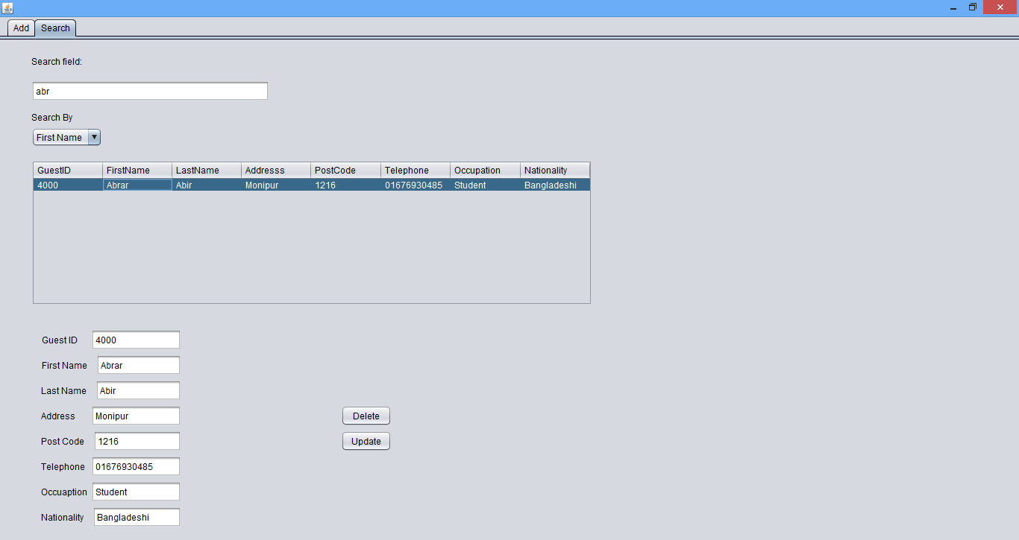

- In this table we can search a guest by his name or id.
- If we want to delete or update the data , we have to select a row of the data and press the update or delete button.
- Full screen this search tab for better view.

Booking Desk :
Bookings :
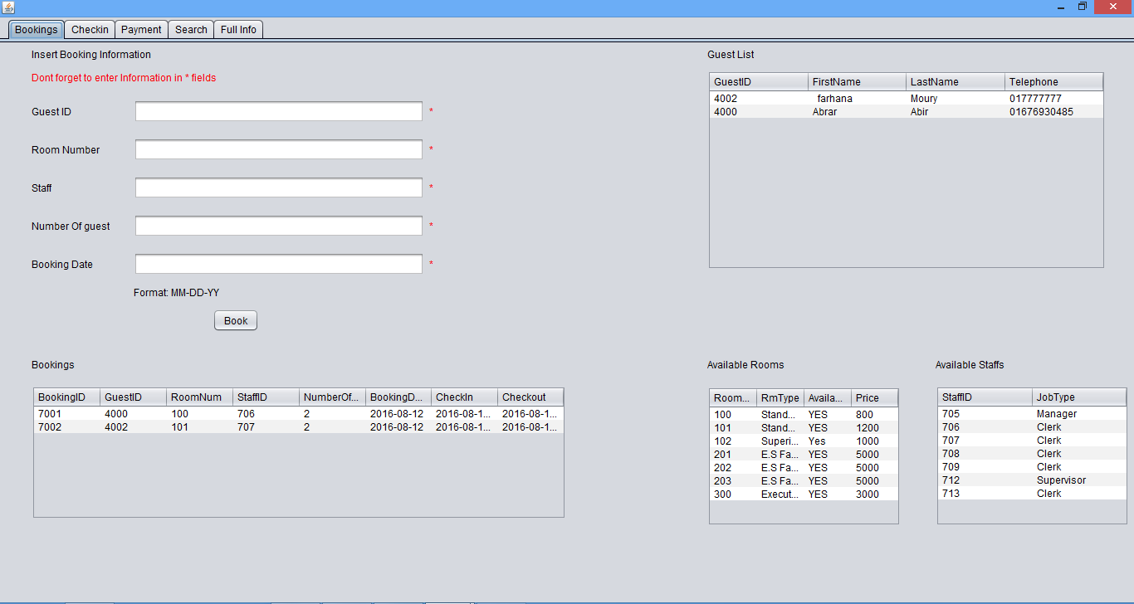

- In this table there is a field to insert a booking information.
- After booking the room it will show in the bookings table.
- There is also a guest list which will show those guests information who are staying in the hotel.
- There is also the available room table where it can show the room type ,availability and price of the room.
- Available staff table shows the staff id and job type.
- This table is pointed out the payment ,staff, room, guest table.
Check In :

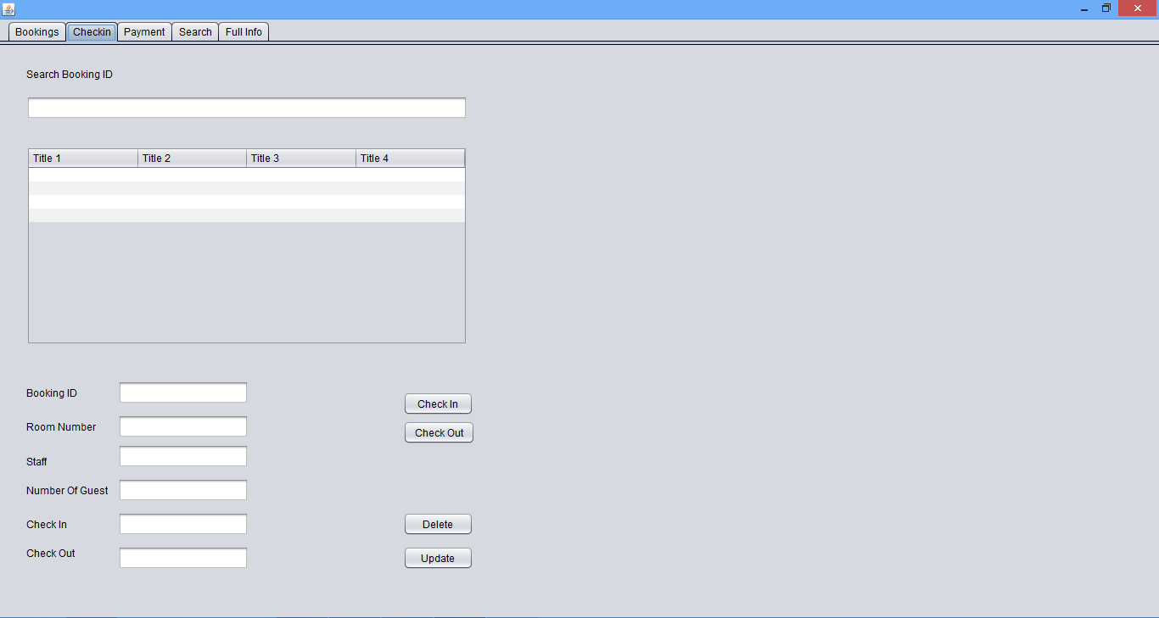

- In this tab we can search the room which has been booked by booking id.
- For checking in or out we have to select a row and then press the button check in or out.
- For updating or deleting the data we have to select a row and then press the update or delete button.
Full Info :

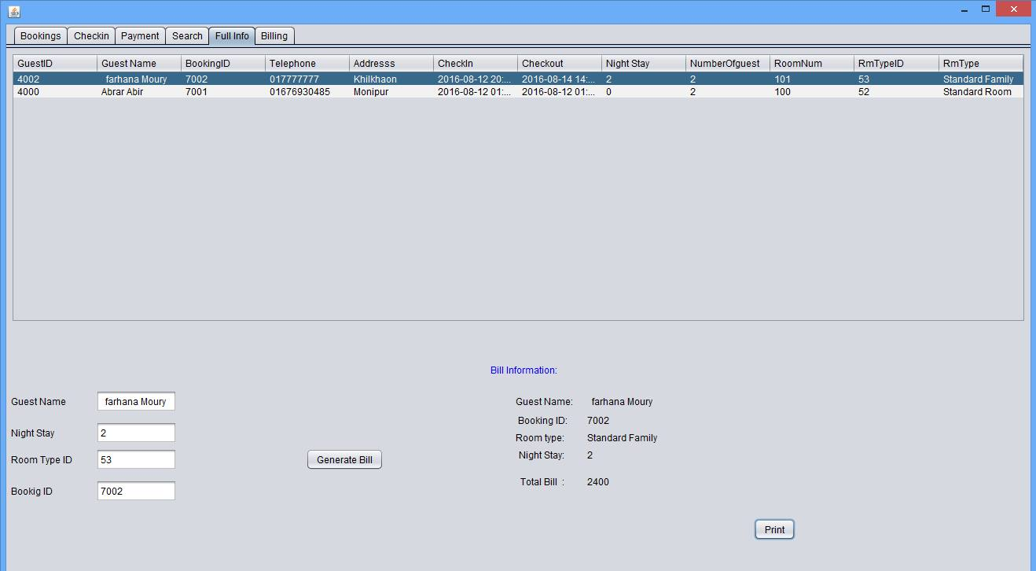

- It shows the full info of the guest.
- If we select any guest id and press the generate bill button , it will show the bill information beside.
- After getting bill information if someone want to print the bill , he or she has to press the button print and he or she will get it.A report file will create in project folder.

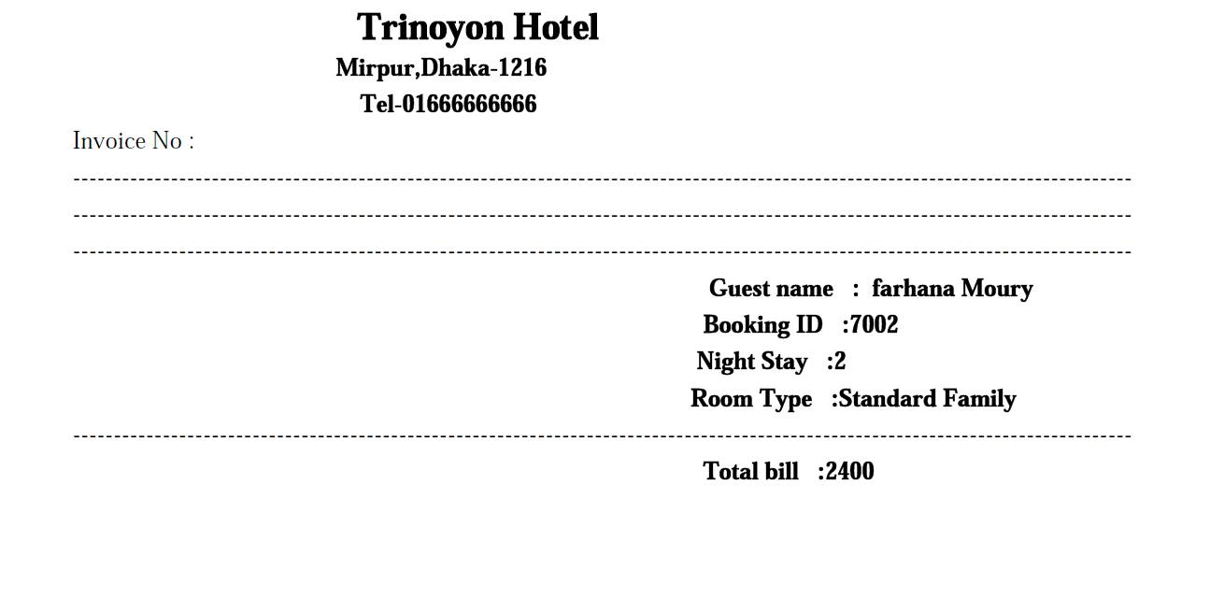
- If we print the bill information , it will look like this.

Payment :
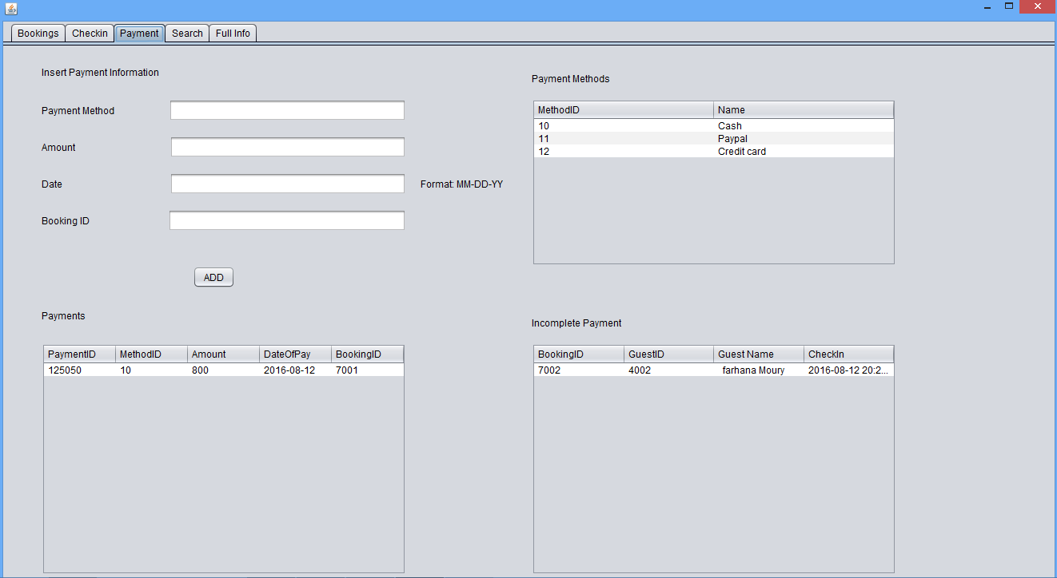

- It contains the payment info.
- There is different type of payment method in this table.
- For paying the bill some info has to be inserted.
- After paying the bill it shows in the table.
- The guest whose payment are due ,it will shows in the Incomplete Payment table by booking Id.
- It points out the payment method and booking table.
Search :
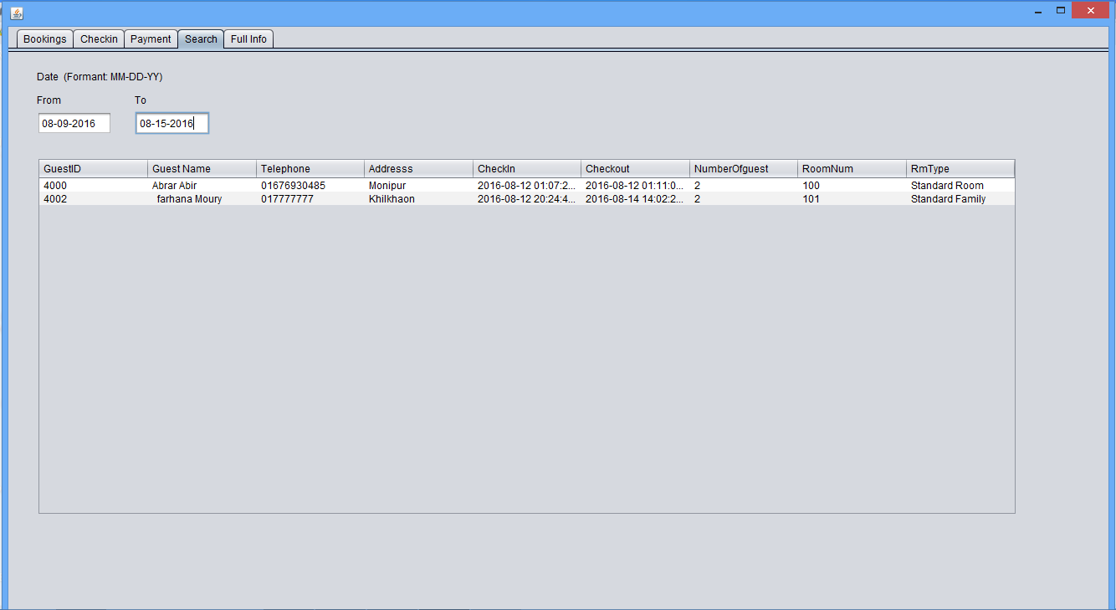

- In this search table it will show those guests list who is staying and checked in and out by a specific date range.
- It also shows the full info about the guest.
Staff & Room :
Rooms :
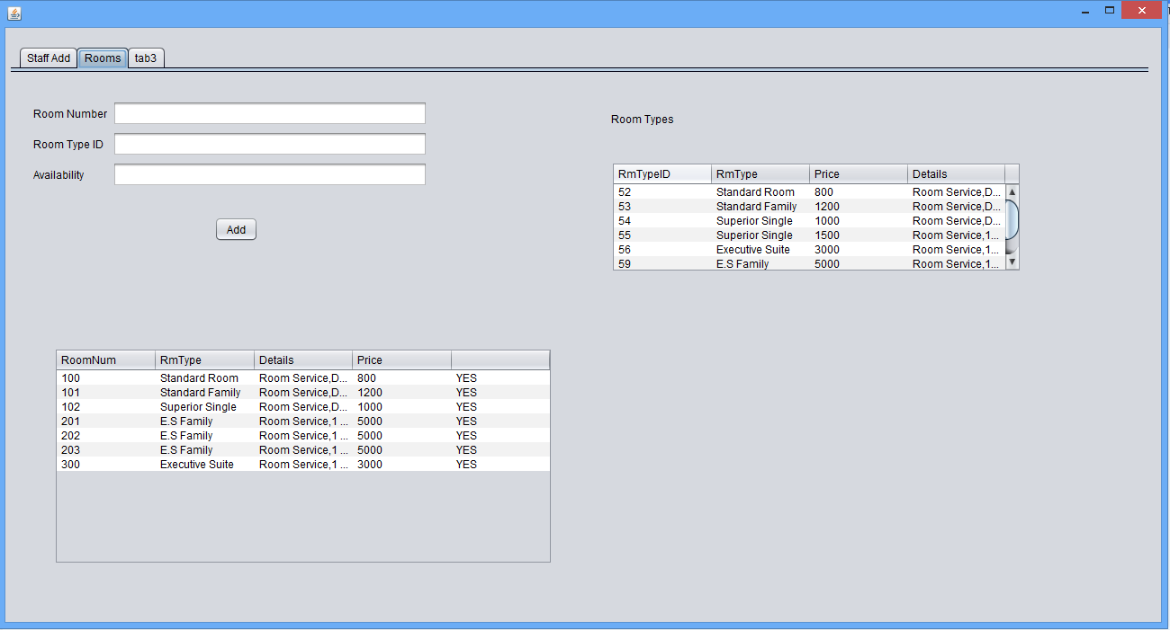

- We can add rooms by filling up info.
- After adding the room it will shows the full info about the room like - availability, room type etc.
- Besides there is the Room Types table where it shows the room type ,id, price and details about the room.By using that we can easily full fill the fields.

Staff Info :

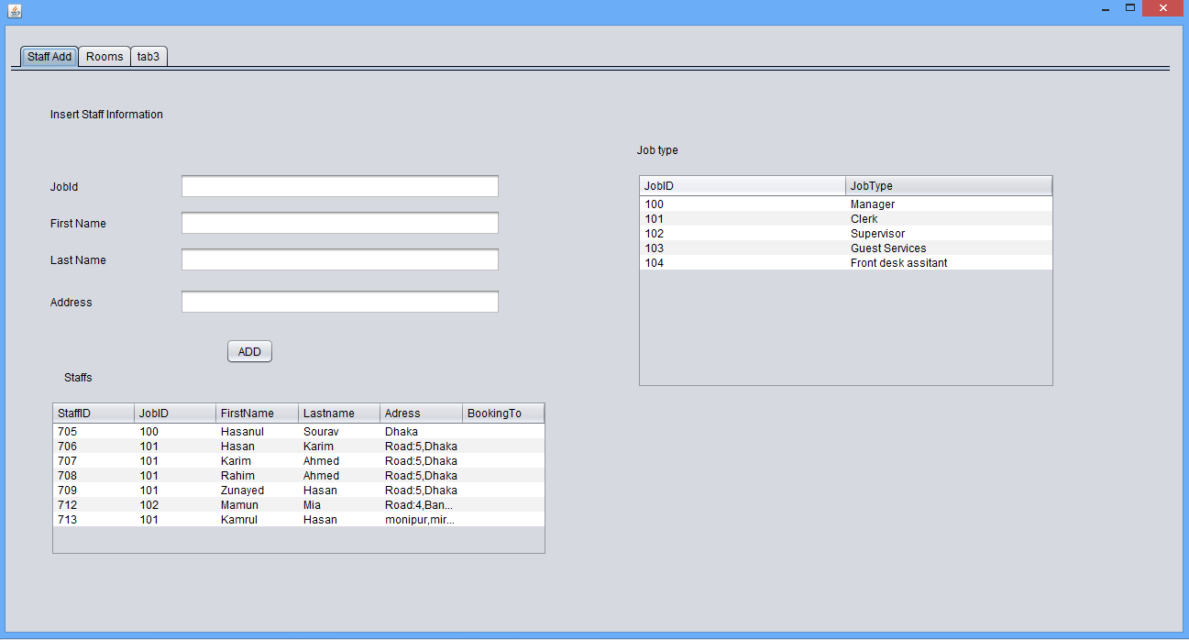

- In this table it contains the staff information.
- To add the staff info we have to fill up the blank field.
- There is a Job type table where it shows the job id and type like - manager, clerk etc.
- After filling up the field it will show in a table Staffs in details.
- Staff table is connected to the booking and job table.
Information Desk :
Booking Info :
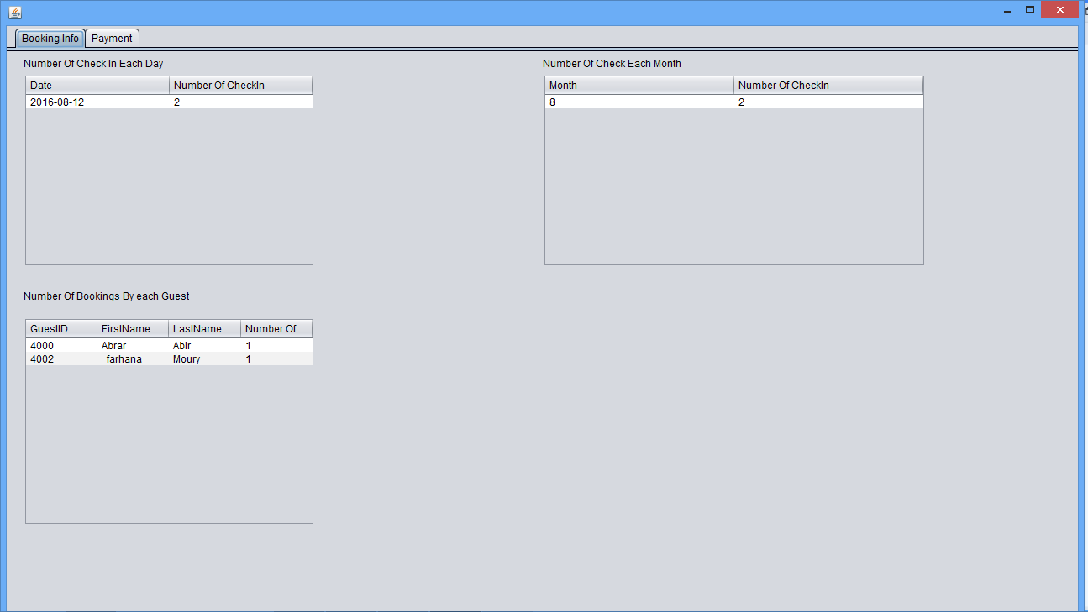

- It shows the booking info.
- it shows no. of check in each day.
- it shows no. of bookings by each guest.
- it shows no. of check each month.

Payment :

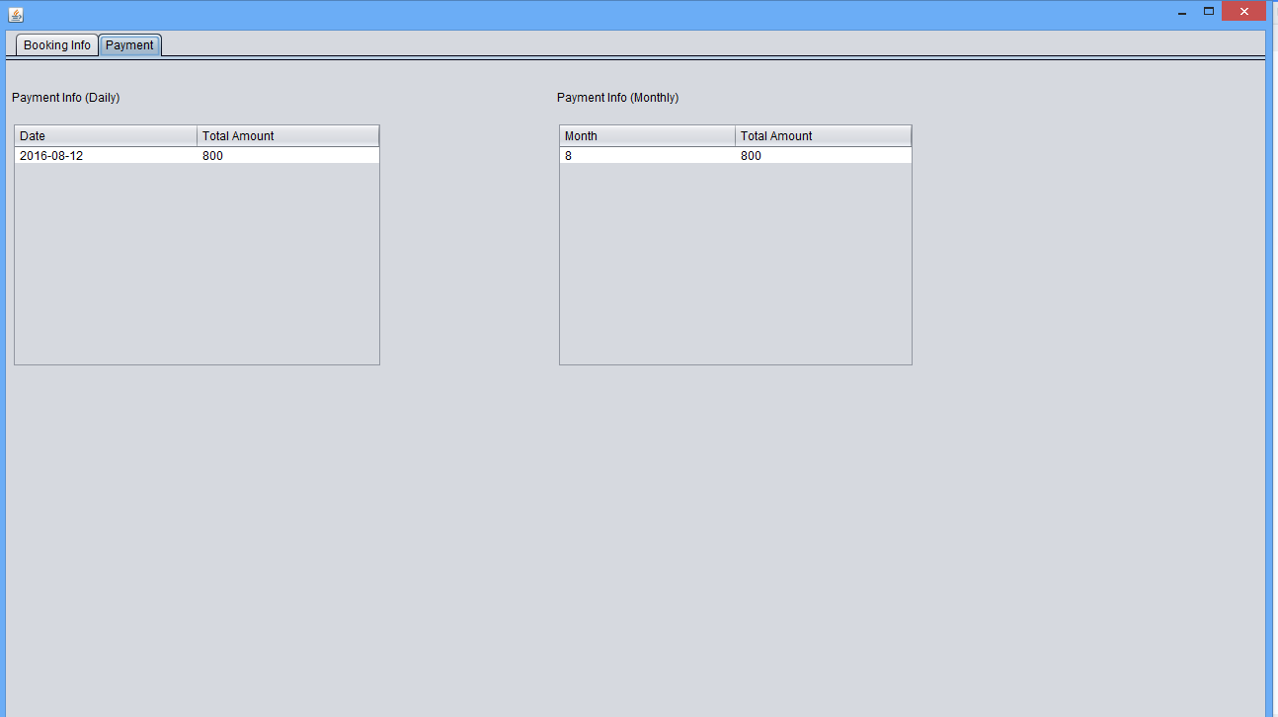

- It shows the payment info daily.
- It shows the payment info per month.

